Gatsby Lecture Series, Part I
“Our Buggy Moral Code” by Dan Ariely
What did Ariely discover about pain?

What did Ariely discover in the math experiment?

What is the “personal fudge factor”?

Attempt to explain what happened with the dollar bills and the Cokes.

What is Ariely’s claim about the “in group” and dishonesty?

Connections to Gatsby
Who is being dishonest in The Great Gatsby thus far?

Why are each of these people being dishonest?

How does Ariely’s theory about the “in group” factor into relationships in The Great Gatsby?

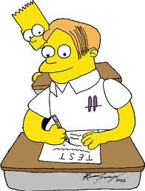

“The Price of Happiness” by Benjamin Wallace
What was the intent of Wallace’s investigation?

What things did he discover were “worth it”? What was not “worth it”?

What did he discover about our relationship to expensive things?

What is the message in this lecture?

Connections to Gatsby
Who in The Great Gatsby is driven by money?

Who is the MOST driven by money?

What is the characters’ relationship with money and possessions?

What non-material things are valued or not valued in the novel?

